- yr Contour surface
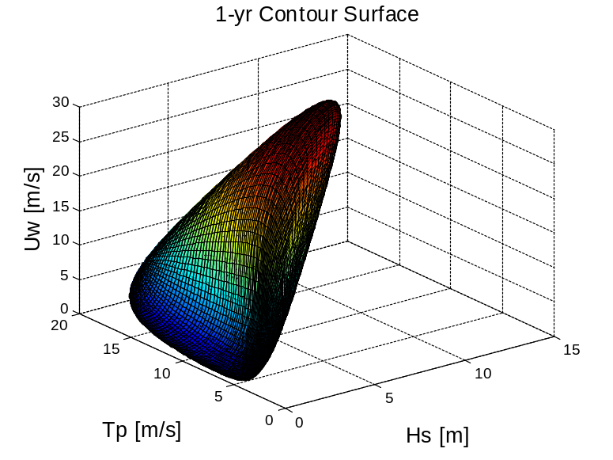
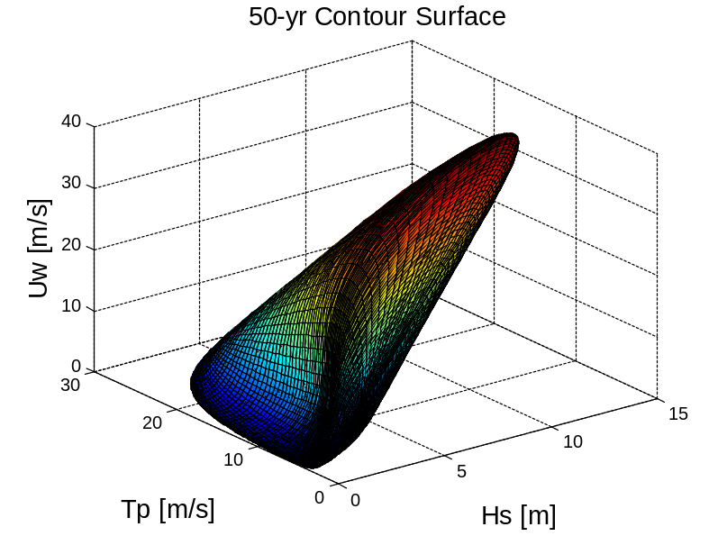
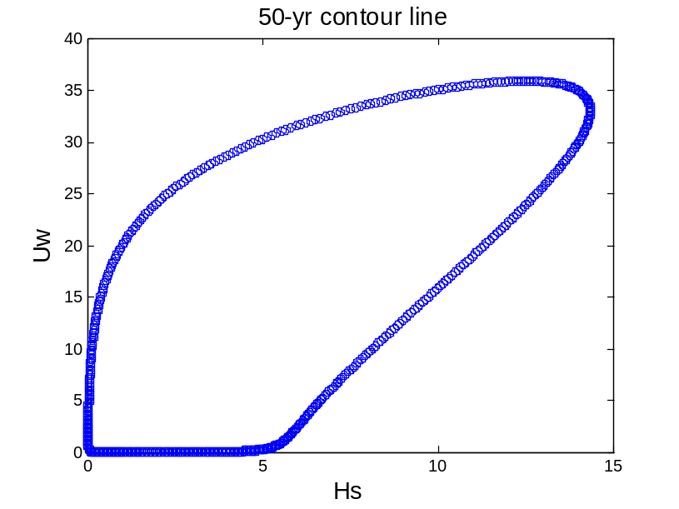
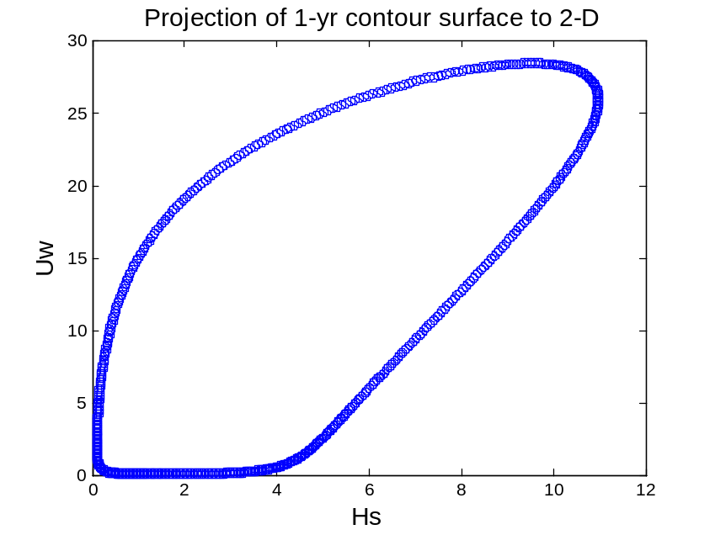
Since the responses of floating spar is less sensitive to the Tp, three cases are selected on the Uw-Hs contour line
1-yr wind and expected Hs and Tp: 30.66, 10.24, 13.14, larger than the contour line value.
50-yr wind and expected Hs and Tp:37.8, 13.1, 14.2
Max Uw:
 | Uw | Hs | Tp
CASE1 | 25.87 | 10.97 | 14.18
CASE2 | 28.43 | 9.53 | 12.90
CASE3 | 27.80 | 10.60 | 13.71
CASE4 (50-yr) | 33.0 | 14.34 | 15.44
The significant wave height for a 1-hour simulation Hs=k2*Hs1, k2=1.09
Uw is extrapolated to the hub height with power factor 0.14, plus a 10% increase in wind speed for scaling the 1-hour average wind speed to 10-min average wind speed.
The real cases run
 | Uw | Hs | Tp | Sigma
Sea state1 | 38.7 | 12.0 | 14.2 | 0.12
Sea state2 | 42.5 | 10.4 | 12.90 | 0.12
Sea state3 | 41.6 | 11.55 | 13.71 | 0.12
Sea state4 | 49.4 | 15.63 | 15.44 | 0.1

- hour long simulation is run, the seed num for each 15 min wind and wave sim. Is different.
Turbulence intensity is a function of wind speed. The U
Sensitivity of the response to the blade azimuth angle position1,2,3
Case1 Standstill-feathered_wind41.7_Hs13.33Tp14.4_no direction
Motion | Tp(s) | f(rad/s)
Surge | 115 | 0.055
Sway | 125 | 0.05
Heave | 31.4 | 0.2
Roll/pitch | 32.7 | 0.19
Yaw | 7.5 | 0.838

Wave freq. =0.436 rad/s

